**Course project-The basics**

**Planning the App**

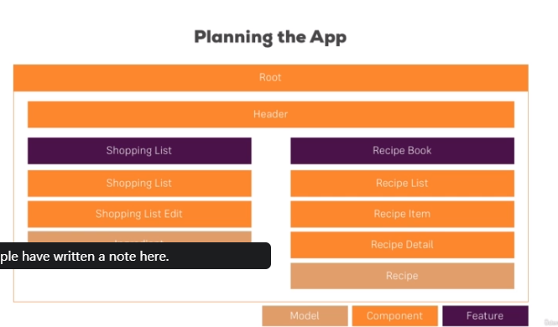

**Setting up the Application**